[CEN 323 ] Computer Organization & Assembly Language
Lab 3 Journal

Name : Fatima Asad
Enrollment Number: 01-135232-020

Lab Deliverables (submission guideline)

Create a folder named after your enrollment number and add the following files:
  - Create a folder named YourRollNumber_Lab3 containing:
- .asm files of all tasks.
- Add the following to the lab journal.
  - Full-screen screenshots of code.
  - Full-screen screenshots of output.
  - Code text.

  - Zip the Folder and upload to LMS.

Lab Task

Task 1:
Code (TEXT):
Addition:
.model small

.data

var1 db 2
var2 db 3
msg db "Addition of two numbers is: ", "$"

.code
main:

mov ax, @data
mov ds, ax
mov dx, offset msg

mov ah, 9
int 21h

mov al, var1
add al, var2

add al, 48

mov dl, al
mov ah, 2
int 21h

mov ah, 4ch
int 21h

end main
Subtraction:
.model small

.data

var1 db 3
var2 db 2
msg db "Subtarction of two numbers is: ", "$"

.code
main:

mov ax, @data
mov ds, ax
mov dx, offset msg

mov ah, 9
int 21h

mov al, var1
sub al, var2

add al, 48

mov dl, al
mov ah, 2
int 21h

mov ah, 4ch
int 21h

end main

Screenshot (CODE):
Addition:
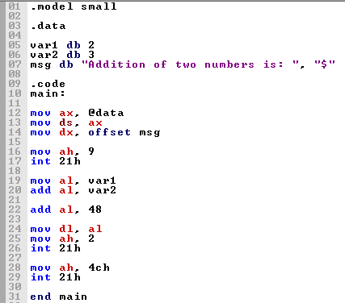
Subtarction:
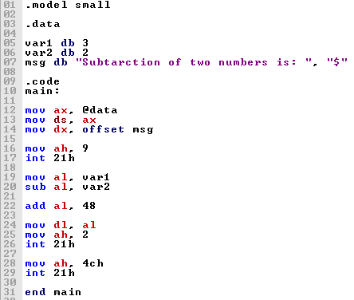

Screenshot (OUTPUT):
Addition:
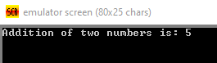
Subtraction:
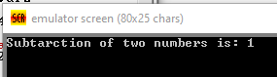

Task 2:
Code (TEXT):
.model small

.data
var1 db "Value of 1st number: ", "$"
num1 db ?

var2 db 10,13,"Value of 2nd number: ", "$"
num2 db ?

msg db 10,13,"Result: ", "$"

.code
main:
mov ax,@data
mov ds,ax
mov dx,offset var1
mov ah,9
int 21h

mov ah,1
int 21h
sub al,48
mov num1,al

mov dx,offset var2
mov ah,9
int 21h

mov ah,1
int 21h
sub al,48
mov num2,al

mov al,num1
mov bl,num2
mul bl
mov bl,al

mov dx,offset msg
mov ah,09h
int 21h

mov dl,bl
add dl,48
mov ah,2
int 21h

mov ah, 4ch
int 21h

end main

Screenshot (CODE):
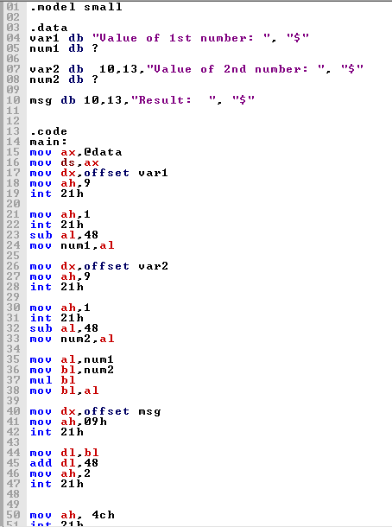
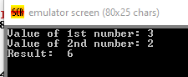

Screenshot (OUTPUT):

Task 3:
Code (TEXT):

Screenshot (CODE):

Screenshot (OUTPUT):

Task 4:
Code (TEXT):

Screenshot (CODE):

Screenshot (OUTPUT):

